cfd_test_04_support_1

**Prepared by: XuZhiqing**

**Date: Thursday, February 09, 2017**

Report Contents

Design 1 2

Scenario 1 2

Materials 2

boundary conditions 3

Initial Conditions 3

mesh 3

Physics 4

Solver Settings 5

Convergence 5

Results 6

Decision Center 8

# Design 1

|  |  |
| --- | --- |
| Length units | cm |
| Coordinate system | Cartesian 3D |

## Scenario 1

### Materials

|  |  |  |
| --- | --- | --- |
|  | | |
| Name | ASSIGNED TO | PROPERTIES |
| Air | Part1.Solid1 | |  |  | | --- | --- | | Density | Equation of State | | Viscosity | 1.817e-05 Pa-s | | Conductivity | 0.02563 W/m-K | | Specific heat | 1004.0 J/kg-K | | Compressibility | 1.4 | | Emissivity | 1.0 | | Wall roughness | 0.0 meter | | Phase | Vapor Pressure | |

### boundary conditions

|  |  |
| --- | --- |
| Type | ASSIGNED TO |
| External Fan(3) | Surface:1 |
| Mass Flow Rate(2.4 lbm/min) | Surface:19 |

### Initial Conditions

|  |  |
| --- | --- |
| Type | ASSIGNED TO |
| Velocity Normal(0 cm/s) | Surface:1 |
| Pressure(0 psi Gage) | Surface:19 |

### mesh

#### Automatic Meshing Settings

|  |  |
| --- | --- |
| Surface refinement | 0 |
| Gap refinement | 0 |
| Resolution factor | 1.0 |
| Edge growth rate | 1.1 |
| Minimum points on edge | 2 |
| Points on longest edge | 10 |
| Surface limiting aspect ratio | 20 |

#### Mesh Enhancement Settings

|  |  |
| --- | --- |
| Mesh enhancement | 1 |
| Enhancement blending | 0 |
| Number of layers | 3 |
| Layer factor | 0.45 |
| Layer gradation | 1.05 |

#### Meshed Model

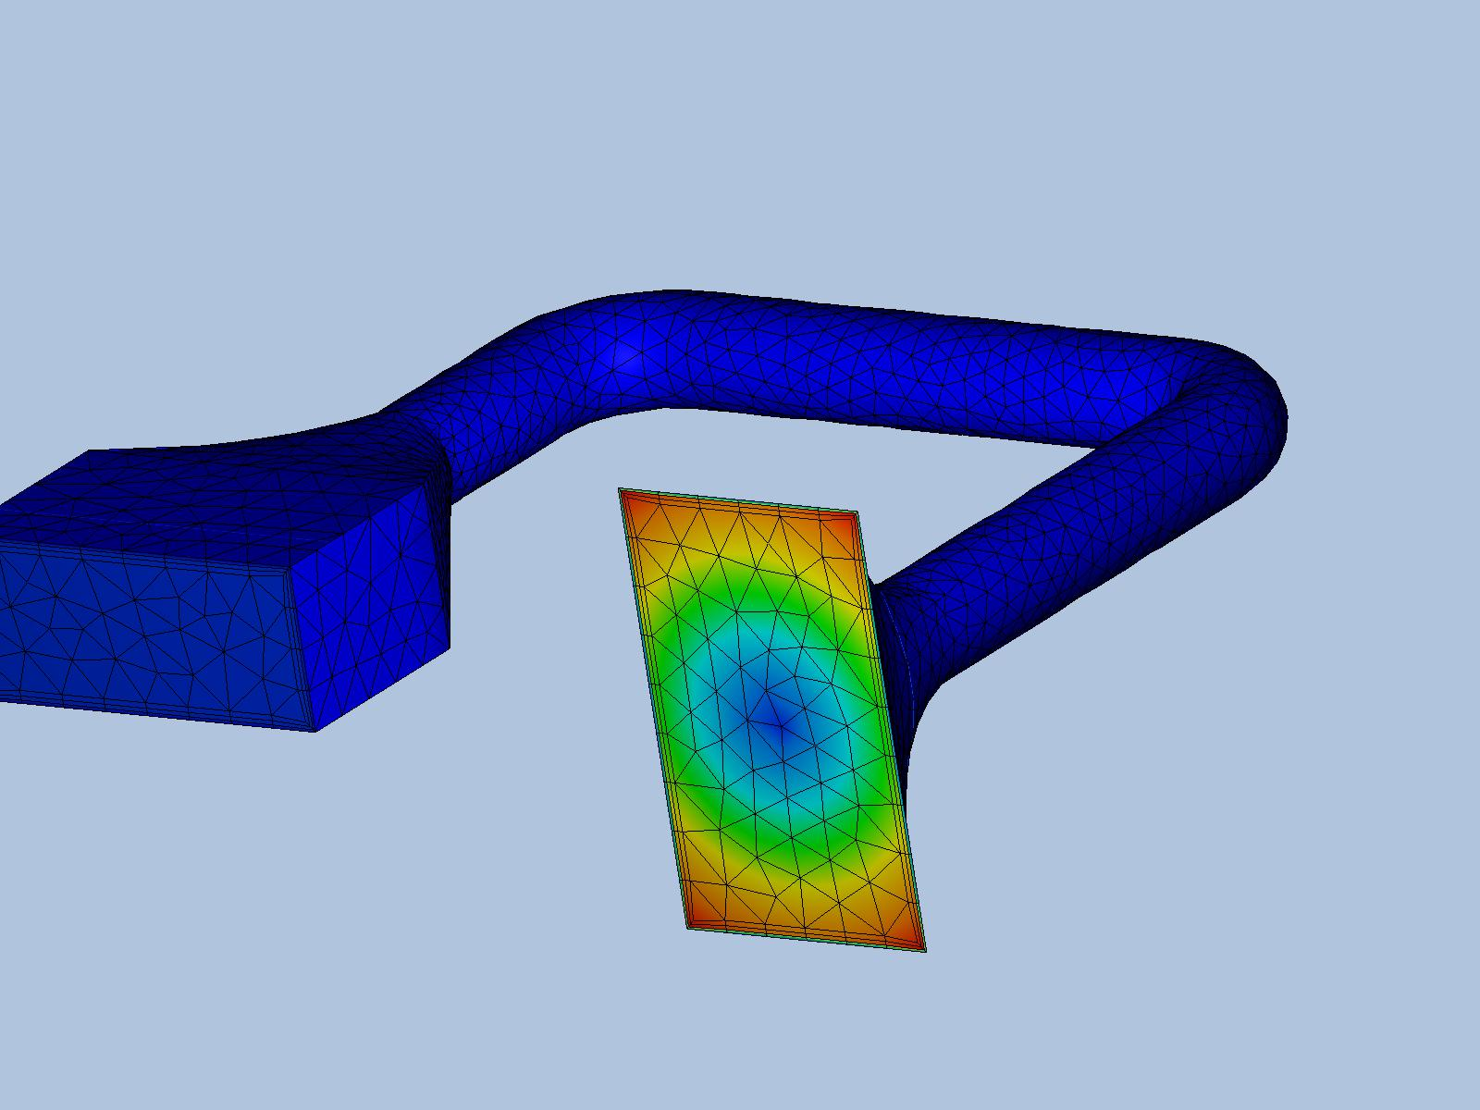

|  |  |
| --- | --- |
| Number of Nodes | 7546 |
| Number of Elements | 21618 |

### Physics

|  |  |
| --- | --- |
| Flow | On |
| Compressibility | Compressible |
| Heat Transfer | Off |
| Auto Forced Convection | Off |
| Gravity Components | 0.0, 0.0, 0.0 |
| Radiation | Off |
| Scalar | No scalar |
| Turbulence | On |

### Solver Settings

|  |  |
| --- | --- |
| Solution mode | Steady State |
| Solver computer | MyComputer |
| Intelligent solution control | On |
| Advection scheme | ADV 5 |
| Turbulence model | k-epsilon |

### Convergence

|  |  |
| --- | --- |
| Iterations run | 500 |
| Solve time | 289 seconds |
| Solver version | 17.0.20160317 |

#### Energy Balance

|  |  |
| --- | --- |
|  |  |
|  |  |

#### Mass Balance

|  |  |  |
| --- | --- | --- |
|  | In | Out |
| Mass flow | -14.7487 g/s | N.A. |
| Volume flow | -12242.32 cm^3/s | N.A. |

### Results

|  |
| --- |
|  |

#### Inlets and Outlets

|  |  |
| --- | --- |
|  |  |
| inlet 1 | |  |  | | --- | --- | | inlet bulk pressure | 20374.2 dyne/cm^2 | | inlet bulk temperature | -0.0 C | | inlet mach number | 0.00314242 | | mass flow in | -18.16 g/s | | minimum x,y,z of opening | 0.0 | | node near minimum x,y,z of opening | 31.0 | | reynolds number | 8586.53 | | surface id | 19.0 | | volume flow in | -15073.9 cm^3/s | |
| inlet 2 | |  |  | | --- | --- | | inlet bulk pressure | 38052.6 dyne/cm^2 | | inlet bulk temperature | 0.0 C | | inlet mach number | 0.0368067 | | mass flow in | 3.4113 g/s | | minimum x,y,z of opening | 0.0 | | node near minimum x,y,z of opening | 4.0 | | reynolds number | 1168.69 | | surface id | 1.0 | | total mass flow in | -14.7487 g/s | | total vol. flow in | -12242.3 cm^3/s | | volume flow in | 2831.58 cm^3/s | |

#### Field Variable Results

|  |  |  |
| --- | --- | --- |
| Variable | Max | Min |
| cond | 0.0002563 W/cm-K | 0.0002563 W/cm-K |
| dens | 0.00120473 g/cm^3 | 0.00120473 g/cm^3 |
| econd | 0.257142 W/cm-K | 0.0002563 W/cm-K |
| emiss | 1.0 | 1.0 |
| evisc | 0.214606 g/cm-s | 0.0001817 g/cm-s |
| gent | 14065.3 1/s | 4.5067 1/s |
| press | 48962.7 dyne/cm^2 | 19023.3 dyne/cm^2 |
| ptotl | 48962.7 dyne/cm^2 | 19023.3 dyne/cm^2 |
| scal1 | 0.0 | 0.0 |
| seebeck | 0.0 V/K | 0.0 V/K |
| shgc | 0.0 | 0.0 |
| spech | 1.004 J/g-K | 1.004 J/g-K |
| temp | 0.0 C | 0.0 C |
| transmiss | 0.0 | 0.0 |
| turbd | 202302000.0 cm^2/s^3 | 2.16843e-05 cm^2/s^3 |
| turbk | 624024.0 cm^2/s^2 | 1.817e-07 cm^2/s^2 |
| ufactor | 0.0 | 0.0 |
| visc | 0.0001817 g/cm-s | 0.0001817 g/cm-s |
| vx vel | 1843.36 cm/s | -1843.36 cm/s |
| vy vel | 1254.81 cm/s | -1353.89 cm/s |
| vz vel | 1527.0 cm/s | -1202.86 cm/s |
| wrough | 0.0 cm | 0.0 cm |

#### Component Thermal Summary

|  |  |  |  |
| --- | --- | --- | --- |
| Part | Minimum Temperature | Maximum Temperature | Volume Averaged Temperature |
| Part1.Solid1 | 0 | 0 | 0 |

#### Fluid Forces on Walls

|  |  |
| --- | --- |
| pressx | -65746.0 dynes |
| pressy | 795.34 dynes |
| pressz | 12266000.0 dynes |
| shearx | 1875.5 dynes |
| sheary | -87.383 dynes |
| shearz | 2115.2 dynes |

# Decision Center